  - Request for Qualifications (RFQ) – Revision 1
Project 2201

Administrative and Maintenance Facility Re-Design Concept

Release Date
Date: 07/07/2022
Update Dates
Rev 1: 07/14/2022
Question/Clarification Deadline
Date: 07/15/2022
Time: 5:00pm (PT)
Submission Deadline
Date: 07/29/2022
Time: 3:00pm (PT)
Procurement Coordinator
Jerome Qiriazi
707-443-0826 x112
jerome@hta.org

Table of Contents
Table of Contents 2
Purpose and Background 3
Current Operations 3
Age of Facility 3
Innovative Clean Transit 3
Scope of Services Requested 5
General Information 6
Procurement Coordinator 6
Anticipated Procurement Schedule 6
Solicitation Document Addenda 6
Examination of Documents 6
Questions and Clarification Requests 7
Contract Terms 7
Incorporation of Documents and Contract 7
Proposal Submittals 7
Proposal Submittal Requirements 7
Submittal Instructions 9
Late Proposals 9
Responsiveness 9
Evaluation 10
Overview 10
Evaluation Process 10
Evaluation Criteria 11
Overview of Award Process 12
Contract Terms and Negotiations 12
Execution of Contract and Notice to Proceed 13
Post Award Meeting 13
Appendix A: Sample Contract 14

Purpose and Background
Humboldt Transit Authority (HTA) was established in 1975 as a joint powers authority (JPA) created by Humboldt County and the cities of Arcata, Eureka, Fortuna, Rio Dell and Trinidad. HTA operates four transit systems: Eureka Transit System (ETS), Redwood Transit System (RTS), Southern Humboldt Transit System (SHTS), and Willow Creek Intercity Transit (WC). HTA also administers and coordinates the Dial-A-Ride service to provide paratransit transportation services, though contracts out to a service provider. The Arcata & Mad River Transit System (A&MRTS) also contracts maintenance services of their fleet vehicles to HTA.
HTA is seeking a firm to assess layout, design, and efficiency of the current administrative and maintenance facility and propose options for updating and improving the facility. This includes location of built infrastructure, fleet circulation and marshalling design, and ability to support the transition to a zero-emission fleet.
HTA is headquartered at 133 V St., Eureka, and owns ten parcels of land and the stretch of W St. between 1st St. and 2nd St., as shown in Figure 1. The three parcels to the north of 1st St. are vacant lots. The existing infrastructure on the seven lots between 1st St. and 2nd St. is shown in Figure 2.

Current Operations
HTA currently operates a fleet of 50 buses, comprised of fifteen (15) 40’ low floor buses, twelve (12) 35’ low floor buses, and twenty six (26) cutaways composed of a mix of 20’, 25’, and 30’ buses. HTA currently employs 11 office staff, 10 maintenance staff, and approximately 30 drivers.

Age of Facility
HTA’s transit yard is a mix of 20-to-50 year old infrastructure that has been pieced together, added on, and modified. Furthermore, HTA’s operations have continued to grow. The age and layout of existing infrastructure is increasingly interfering with efficiency of operations.

Innovative Clean Transit
The Innovative Clean Transit rule requires all transit systems in California to transition to zero emissions fleets. HTA has conducted extensive studies on fuel cell electric (FCEB) and battery electric (BEB) buses. HTA will be pursuing FCEBs to serve the large majority, if not all, revenue miles serviced by HTA. HTA currently operates one BEB on RTS, will be managing BEBs for A&MRTS, and may manage additional BEBs in the future.
HTA anticipates an award from the Transit and Intercity Rail Capital Program (TIRCP) grant which, among other efforts, will fund the construction of a hydrogen fueling station and the procurement of eleven FCEBs.
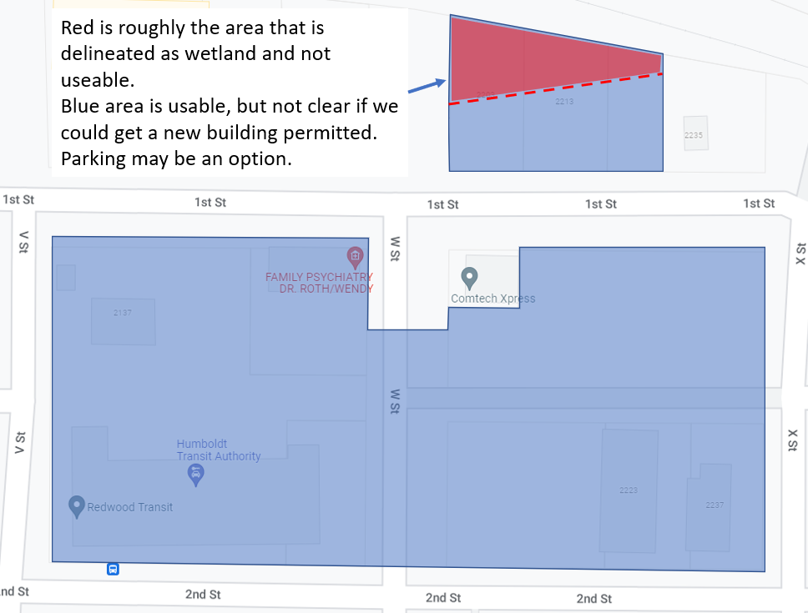
Figure 1: Property owned by HTA is shown in blue. The red shaded area (also owned by HTA) indicates portion of property that is not usable.

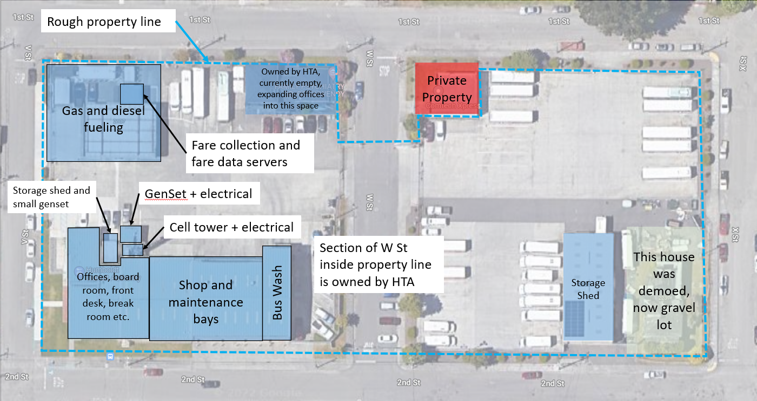
Figure 2: Existing infrastructure

Scope of Services Requested
HTA is requesting qualifications for services from highly competent, creative, and forward-thinking architects to propose an updated design of HTA’s administrative and maintenance facility that:
- Better serves existing and projected future operations,
- Accommodates the transition to zero emission fleets, and
- Solidifies the location and footprint of the hydrogen fueling station that will be funded by TIRCP.
The design must:
- Propose a vehicle circulation and movement plan for all on-sight vehicles, including marshalling for maintenance activities,
- Propose the ideal location of all on-sight infrastructure,
- Estimate and account for growth projections in fleet size and operations,
- Include designs of all proposed new and/or retrofitted buildings and infrastructure,
- Include a timeline for engineering, permitting, procurement, and construction.
Vehicle circulation and marshalling should prioritize and maximize safety, maximize the efficient use of space, and should consider on-sight pedestrian and employee vehicle circulation. The design of new buildings and infrastructure should consider reach codes beyond CalGreen requirements. Thermal comfort modeling should be applied to all exterior spaces to maximize a healthy and pleasant work environment.
The design should be completed in three phases:
- Phase 1: 2D mapping of proposed vehicle circulation, and location and draft footprint of all existing, retrofitted, and/or new infrastructure,
- Phase 2: Completion of 30% schematic design of all proposed new, retrofitted, and/or otherwise modified infrastructure, not inclusive of hydrogen fueling infrastructure, along with an estimate of project cost sufficient for inclusion in one or more grant proposals, and
- Phase 3: Completion of a complete set of constructions documents (construction set and permit set), inclusive of all proposed new, retrofitted and/or modified infrastructure.
Responses should include an estimated schedule for each phase (assuming all funding is in-hand), with a preference for faster timelines. Phase 1 should be completed by December, 2022 in order to align with the TIRCP project schedule.
Initiation of Phase 3 is likely contingent on HTA’s application and receipt of additional funding, the source of which is to be determined. Phase 2 may also require additional funding, depending on cost negotiations. HTA anticipates that current funding in hand is sufficient for completing the large majority, if not all, of Phases 1 and 2.

General Information

Procurement Coordinator
All questions and communication concerning this solicitation must be directed to the Procurement Coordinator listed below. All oral communication will be considered unofficial and non-binding. Proposers are to rely solely on written statements issued by the Procurement Coordinator.
Procurement Coordinator: Jerome Qiriazi
Email: jerome@hta.org
Address: 133 V St.
Eureka, CA 95501

Anticipated Procurement Schedule
The activities and dates listed in Table 1 represent the anticipated procurement schedule. HTA reserves the right to change the schedule. The Procurement Coordinator will post any changes on HTA’s website at https://www.hta.org.
Table 1: Anticipated procurement schedule.
Procurement Activity | Date and Time (Pacific Time)
RFQ Release | July 7th, 2022
Pre-Proposal Meeting | N/A
Questions and Requests for Clarification Due | July 15th, 2022 at 5:00pm
Proposal Due | July 29th, 2022 at 3:00pm
Evaluations, Interview, and Negotiations | August, 2022
Anticipated Award Date | August 15th, 2022
Anticipated Start Date | September 1st, 2022

Solicitation Document Addenda
Solicitation documents may be accessed on-line at https://www.hta.org. The Procurement Coordinator will post a written statement of any changes at this URL. Proposers are responsible for checking for updates and obtaining any Addenda and changes related to this solicitation. Failure to do so may result in the submission of a proposal that is inconsistent with the most current information and may result in disqualification.

Examination of Documents
Proposer must thoroughly examine all solicitation documents, including but not limited to, the RFQ, any other material referenced or incorporated herein, and any Addenda. Submission of a proposal constitutes acknowledgment that the proposer has thoroughly examined all solicitation documents.
Proposer’s failure or neglect to receive or examine any of the solicitation documents, statutes, ordinances, regulations and permits will in no way relieve the proposer from any obligations with respect to the proposal or any resulting contract.
HTA will reject claims for additional compensation based upon a lack of knowledge or misunderstanding of any of the solicitation documents, statutes, ordinances, regulations, permit requirements, or other materials referenced or incorporated in this RFQ.

Questions and Clarification Requests
Proposer questions and/or requests for clarification regarding this RFQ will be allowed consistent with the respective dates specified in the Anticipated Procurement Schedule. All Proposer questions and/or requests for clarification must be submitted in writing via email to the Procurement Coordinator. It is at HTA’s sole discretion to accept or reject any request for changes.
The Procurement Coordinator will provide an official written response to proposer questions received by the respective deadlines. Proposers must not rely on any oral statements or conversations, whether at the Pre-Proposal Meeting (if applicable) or otherwise, with HTA representatives for questions or clarifications regarding this RFQ. Verbal responses to questions and/or clarifications will be considered unofficial and non-binding. Only written responses provided by the Procurement Coordinator and posted to https://www.hta.org in the form of an addendum will be considered official and binding. All such addenda will become part of the solicitation and any awarded contract.
If no requests for clarification are received, HTA will construe silence as acceptance and that the Proposer intends to comply with the solicitation documents as written in their entirety.

Contract Terms
A sample contract has been included in Appendix A. HTA anticipates the final contract signed by the successful proposer to be substantially the same as the sample contract. Proposer’s submission of a response to this solicitation constitutes general acceptance of these contract requirements.
The foregoing should not be interpreted to prohibit either party from proposing additional contract terms and conditions during negotiation of the final contract.

Incorporation of Documents and Contract
A proposal submitted in response to this solicitation is an offer to contract with HTA. This solicitation document, all incorporated documents, any subsequent addenda, and the successful proposer’s response will be incorporated by reference into the resulting contract.

Proposal Submittals

Proposal Submittal Requirements
- Cover Letter
A signed cover letter should be on company letterhead clearly stating the name of the proposer’s firm, business address, telephone, and e-mail address. The following information must be provided:
  - Name(s) of authorized principals with authority to negotiate and contractually bind the firm.
  - A statement that binds the proposer to the submitted response for at least sixty (60) calendar days from the date of submission.
- Proposer Information
Proposer must submit a brief profile of the firm, and include contact information for an authorized representative.
- Subcontractor Information
HTA will accept proposals that include third party involvement only if the proposer submitting the proposal agrees to take complete responsibility for all actions of such subcontractors. Proposer must disclose the use of any subcontractor(s) in their proposal.
If applicable, proposer will identify all subcontractors who will perform services in fulfillment of contract requirements, including at a minimum their name, the nature of services to be performed, address, telephone, and email. HTA reserves the right to approve or reject any and all subcontractors that proposer proposes. Any subcontractors not listed in the proposer’s response, who are engaged after award of the contract, must be pre-approved, in writing, by HTA before providing services under the contract.
- References
Proposer must submit a minimum of three (3) references for which the proposer has provided services similar to those described in the Scope of Services Requested section.
Through this submission, proposer grants permission to HTA to independently contact the references. HTA reserves the right to obtain and consider information from other sources concerning a proposer, such as proposer’s capability and performance under other contracts, proposer’s financial stability, past or pending litigation, and other publicly available information.
- Technical Statement of Qualifications
Proposer must provide sufficient detail on the proposer’s qualifications (including subcontractors if applicable) that will be used to evaluate and score the proposer’s ability to perform the requested scope of services. At a minimum this should include a description of:
  - Past performance and experience with similar projects,
  - Technical ability to perform the requested services, and
  - Innovative and creative ideas on how the firm will approach the project.
- Project Schedule
Proposer must include a schedule for completing each phase of the requested scope of services, and detail their ability to meet the Phase 1 target deadline.
- Hourly Rates
Proposer shall specify hourly rates for at least three (3) and maximum of seven (7) key job classifications for the project, including the job classification for the likely project manager. Hourly rates shall be submitted for all prime contractors and subcontractors. Hourly rates shall be inclusive of all fees for service, profit, overhead, travel, materials, escalation, and taxes. Hourly rates shall be presented for the time frame of the proposed project schedule. All prices shall be in U.S. Dollars. Hourly rates are subject to negotiation prior to award. Hourly rates must be presented using the following fee schedule
Classification | Project Role | Hourly Rates
 |  | Hourly Rate ($) | Overhead Rate (%) | Fee/Profit (%)
Classification 1
Classification 2
Classification 3
:
Administrative
Escalation
Other Costs / Fees

Submittal Instructions
To receive consideration, the Procurement Coordinator must be in possession of the proposer’s submission prior to the deadline indicated in Anticipated Procurement Schedule. The proposer must submit all materials either electronically by email to the Procurement Coordinator, by mail in sealed envelopes to the Procurement Coordinator’s attention, or in person in sealed envelopes to the Procurement Coordinator’s attention.
Proposals submitted electronically are allowed to have electronic signatures or scanned wet signatures on the cover page. Electronic submissions must be formatted as PDF and/or Microsoft Office documents as applicable. Total email size must be less than 10.0MB. If the total size of all submitted materials is greater than 10.0MB, multiple emails are allowed and must have clearly numbered and sequential subject titles. All file names must clearly identify that they all belong to the same proposal.
Hourly rate information must be submitted as a separate file, either as a separate electronic file that is appropriately named if submitted electronically, or in a separate sealed envelope that is appropriately labeled if mailed or delivered in person.

Late Proposals
Any proposal received after the exact time specified for the due date and time will not be accepted or receive consideration. The exact time is designated as the date and time received by the Procurement Coordinator.

Responsiveness
Proposer must respond to each question/requirement contained in this RFQ. Failure to demonstrate to HTA that your firm meets the RFQ requirements and/or comply with any applicable item may result in the response being deemed non-responsive and disqualified from further consideration.
HTA, at its sole discretion, reserves the right to consider the actual level of proposer’s compliance with solicitation requirements, accept or reject any and all proposals received, waive any irregularities or minor informalities, to accept any items or combination of items, and to request additional information required to fully evaluate a proposal.

Evaluation

Overview
The responsive responsible proposer whose proposal is determined to best meet all RFQ requirements and is the most advantageous to HTA, based on the evaluation factors described herein, will be declared the successful proposer. All proposals are subject to HTA’s final approval as to whether they meet all RFQ requirements.

Evaluation Process

Initial Determination of Process (pass/fail)
Responses will be reviewed initially by the Procurement Coordinator to determine on a pass/fail basis compliance with administrative requirements as specified in this RFQ. Only responses that meet this requirement will move to the next evaluation step.
HTA reserves the right to determine at its sole discretion whether the proposer’s response meets the responsiveness criteria as set forth within this document. If all responding proposers are determined to be deemed non-responsive, HTA will cancel the solicitation and reject all proposals. Only responses that pass the initial determination of responsiveness review will be further evaluated based on the requirements in this solicitation.

Phase 1 Evaluation (scored)
HTA will establish an evaluation committee to evaluate all proposals. The evaluation committee will evaluate and score the proposals using the criteria and scoring set forth in the Evaluation Criteria section. The evaluation committee will be comprised of at least two HTA staff. At the discretion of HTA, the evaluation committee may also include subject matter experts outside of HTA. The procurement coordinator will tabulate the evaluation committee’s scoring. HTA will calculate a single score for each proposer. A proposer must receive a minimum score of 70% of the total available points in the First Evaluation to be considered responsive.
Evaluation points will be awarded for the following submittal requirements and methods:
Technical Statement of Qualifications Evaluation: The evaluation committee will evaluate and score the proposer’s response to the Technical Statement of Qualifications section of the Proposal Submittal Requirements. If applicable, the proposer must include qualifications of subcontractors. The maximum number of points is detailed in the Evaluation Criteria section.
Points will be awarded based on the expert opinion of the evaluation committee regarding how well the proposer addressed this submittal requirement.
Quality of Responsiveness: The evaluation committee will evaluate the quality with which the proposer provides sufficient detail in the responses to the Proposal Submittal Requirements. This includes ability to instill confidence in the proposed project team, and examples of relevant projects provided that express creative solutions. The maximum number of points is detailed in the Evaluation Criteria section.
Points will be awarded based on the expert opinion of the evaluation committee regarding how well the proposer addressed this submittal requirement.
Project Schedule Evaluation: The evaluation committee will evaluate and score the proposer’s response to the Project Schedule section of the Proposal Submittal Requirements. The maximum number of points is detailed in the Evaluation Criteria section.
An overall shorter project timeline across all phases will receive a higher evaluation score.
Local Vendor Preference: The proposer must indicate if they qualify as a local vendor. If the proposer is claiming local vendor preference, the proposer must include a copy of their business license. A local vendor is defined as meeting both of the following conditions:
- Conducts business in an office with a physical location within the County of Humboldt, and
- Holds a valid business license issued by the County of Humboldt or any City within the County.
A proposer who is a local vendor will receive 5 points, as required by HTA’s procurement policy. Inclusion of a local vendor as a subcontractor does not satisfy this requirement. HTA will uphold or deny local vendor status if such status is challenged or considered a subterfuge.

Competitive Range Determination
Once all proposals are scored, a “competitive range” will be determined on the basis of overall rankings according to the weighted criteria set forth herein. Proposers determined to be within a competitive range may be notified in writing to provide additional information and/or clarification. Proposers in the competitive range may be invited to an Optional Phase 2 Evaluation. In such an event, HTA will not provide any information to any proposer regarding the relative standing among the others.

Optional Phase 2 Evaluation (scored)
HTA reserves the right to schedule Interviews if determined to be in the best interest of HTA. In the event an interview is required, HTA will contact the proposer(s) within a competitive range to schedule an interview date, time, and location. Commitments made by the proposer during the Interview, if any, will be considered binding. A score of up to 105 additional points will be awarded for the interview. The proposer’s interview score will then be added to the proposer’s total Phase 1 Evaluation score in determining the proposer’s final score. The proposer with the highest overall point total will be identified as the apparent successful proposer.

Optional References (pass/fail)
HTA reserves the right to check references after proposal submittal, to assist in determining the overall responsibility of the proposer. References may be checked during proposal evaluation to determine the responsibility of proposers. HTA reserves the right to reject any proposal submittal if the proposer receives unfavorable references and may use results as a factor in award. HTA reserves the right to seek and substitute other references to determine the sufficiency of the proposer’s level of responsibility.

Evaluation Criteria
HTA will evaluate proposals on the basis of technical merit as detailed in the Evaluation Process section. The scores for each proposal will be assigned a relative importance for each scored section, listed in order of importance in the following subsections.
The evaluation process can include two steps, with the second step optional. If it is deemed to be in the best interest of HTA to only complete the First Evaluation, there are a maximum of 105 points available. If it is deemed to be in the best interest of HTA to complete both the First and Second Evaluations as described in the Evaluation Process section, there are a maximum of 210 points available. It is solely within HTA’s discretion to initiate the second evaluation.

First Evaluation
The evaluation criteria and assigned points are shown in Table 2.
Table 2: First evaluation criteria.
Requirements | Max Points
Technical Statement of Qualifications Evaluation | 50
Quality of Responsiveness | 35
Project Schedule Evaluation | 15
Local Vendor Preference | 5
Total Possible Points | 105

Second Evaluation (Optional)
The evaluation criteria and assigned points are shown in Table 3.
Table 3: First evaluation criteria.
Requirements | Max Points
Interview | 100
Local Vendor Preference | 5
Total Possible Points | 105

Overview of Award Process
The apparent successful proposer, if any, will be the responsive, responsible, qualified proposer whose proposal, in the sole opinion of HTA, best meets the requirements set forth in this RFQ and is in the best interest of HTA. HTA may enter into contract negotiations with the apparent successful proposer.
All responsive proposers responding to this solicitation will be notified when HTA has determined the apparent successful proposer.
If HTA and the apparent successful proposer are unable to negotiate an acceptable contract within a reasonable amount of time, HTA will terminate negotiations and may proceed to negotiations with the next highest ranked proposer.
The HTA General Manager will make a recommendation of the apparent successful proposer to the HTA Board. If the Board concurs, a contract will be awarded to the apparent successful proposer.

Contract Terms and Negotiations
The objective of negotiations is to reach agreement on all provisions of the proposed contract. To assist in the negotiations, a sample contract is included in Appendix A.
HTA may request negotiation of proposer’s hourly rates. If requested, proposer agrees, within seventy-two (72) hours of entering into contract negotiations, to permit access to financial records to verify labor rates, overhead rates, and other information should HTA determine that such information is required to determine if the proposed hourly rates or fees are fair and reasonable.

Execution of Contract and Notice to Proceed
The successful Proposer will execute the final contract in duplicate and return to HTA within ten (10) business days of its receipt. After execution by HTA, one (1) original signed contract will be returned to the awarded contractor.

Post Award Meeting
The awarded contractor may be required to attend a post award meeting scheduled by the Procurement Coordinator to discuss contract performance requirements. The time and place of this meeting will be scheduled following contract award.

Appendix A: Sample Contract

